**Project Design Phase-II**

**Data Flow Diagram & User Stories**

|  |  |
| --- | --- |
| Date | 10 October 2022 |
| Team ID | PNT2022TMID48683 |
| Project Name | Early Detection of Chronic Kidney Disease using Machine Learning |
| Maximum Marks | 4 Marks |

**Data Flow Diagrams:**

A Data Flow Diagram (DFD) is a traditional visual representation of the information flows within a system. A neat and clear DFD can depict the right amount of the system requirement graphically. It shows how data enters and leaves the system, what changes the information, and where data is stored.

**Example:** [**(Simplified)**](https://developer.ibm.com/patterns/visualize-unstructured-text/)

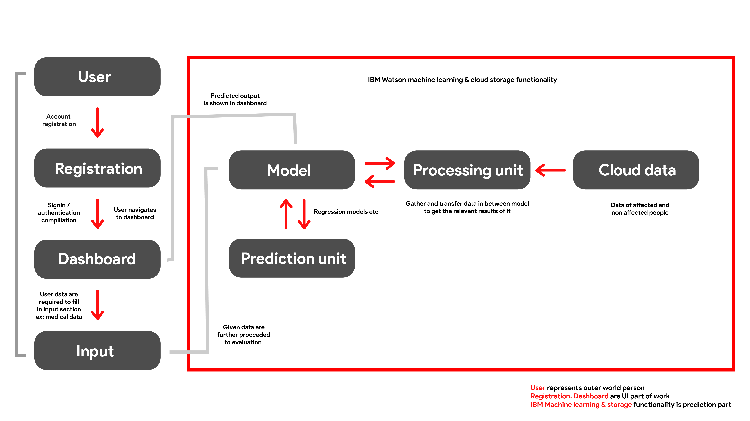

**[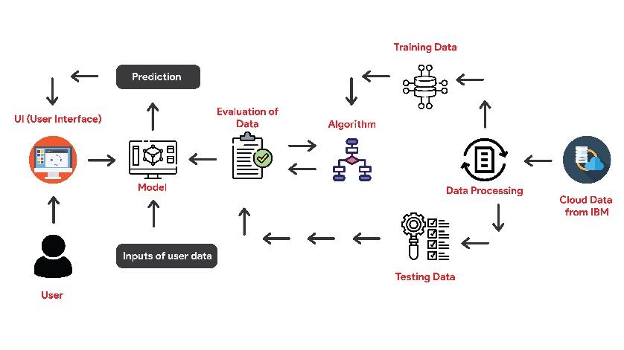](https://developer.ibm.com/patterns/visualize-unstructured-text/)**

**User Stories**

Use the below template to list all the user stories for the product.

| **User Type** | **Functional Requirement (Epic)** | **User Story Number** | **User Story / Task** | **Acceptance criteria** | **Priority** | **Release** |
| --- | --- | --- | --- | --- | --- | --- |
| Customer (Web user) | Registration | USN-1 | User can sign in to our web application by using google account | User will proceeded to google sign authentication automatically | High | Sprint-1 |
|  |  | USN-2 | Users are considered to fill the google form for further authentication | To make the user well aware of what they going to get from the web application we build and further details about the user | Medium | Sprint-1 |
|  |  | USN-3 | User log in data is stored and surveillance by google firebase authentication service | Security purpose user data are stored and well secured using google authentication service | High | Sprint-1 |
| Customer (Web user) | Login | USN-4 | User now successfully registered using google authentication service | Now user is moved to main application back with successful login | High | Sprint-1 |
| Customer (Web user) | Dashboard | USN-5 | Now user is preferred to enter the medical details to analyse their disease severity or whether they have that disease | Prediction of disease | High | Sprint-2 |
| Customer (Web user) | Dashboard | USN-6 | There are three values which should be given in float or numerically | Blood glucose random, Blood urea etc | High | Sprint-3 |
| Customer (Web user) | Dashboard | USN-7 | There are some other valuers which are fulfilled by alpha values whether they have or not (yes or no questions) | Anemia, Petal edema, Coronary disease | High | Sprint-3 |
| Customer (Web user) | Dashboard | USN-8 | After fulfilment of user medical values the prediction of disease is analysed by machine learning model that present in the IBM Watson machine learning platform | The IBM Watson machine learning platform will process the data given by the user and operates model given in it and result will be given to the user in the web application | High | Sprint-4 |